**Test Case 1: Successful IA Suggestion Search SUCCESS**

* **Preconditions**: Valid locations exist in the database.
* **Steps**:
  1. Enter valid criteria in the "IA Suggestion" field (e.g., " partner location, in Porto “").
  2. Submit the request.
* **Expected Result**: The map displays only the locations that match the criteria.

BEFORE:  
AFTER Applying filter **not verified spot in porto with good view**

one of the spots   
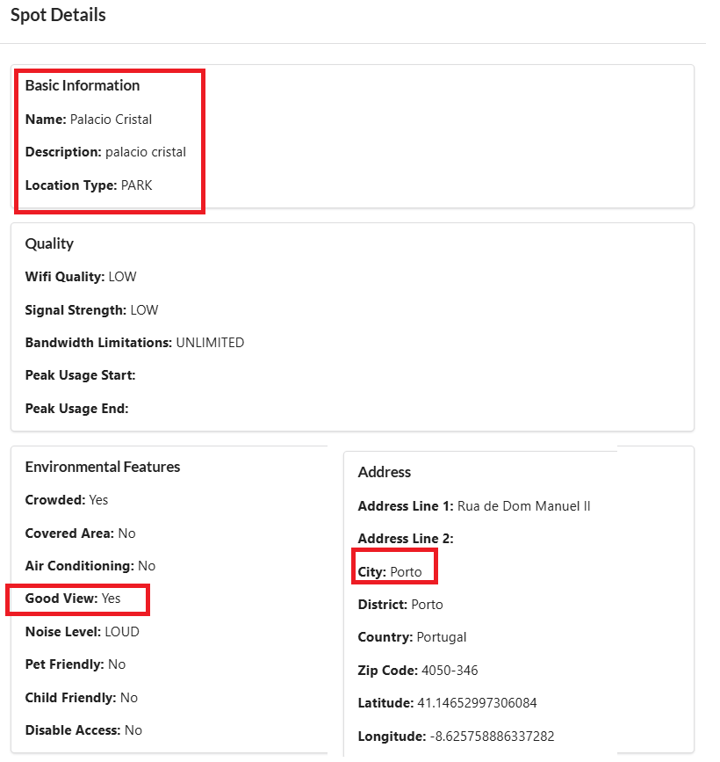

**Test Case 2: No Matching Locations SUCCESS**

* **Preconditions**: No locations in the database match the entered criteria.
* **Steps**:
  1. Enter criteria that have no matches (e.g., "in the city called moon").
  2. Submit the request.
* **Expected Result**: The system displays "No locations found."

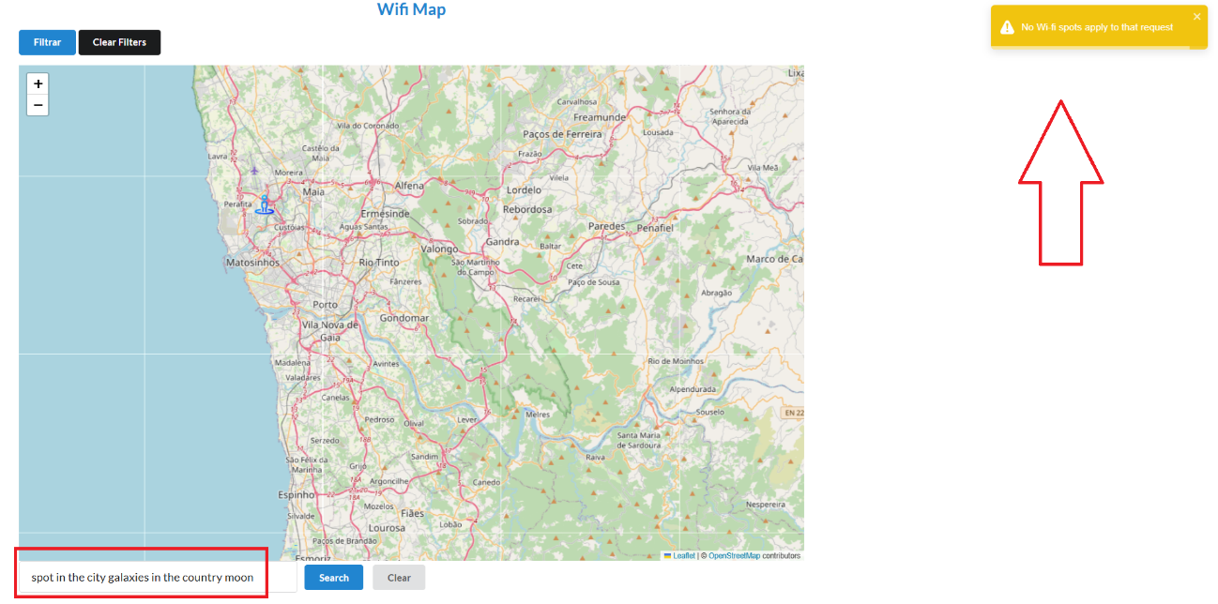

**Test Case 3: Invalid Input SUCCESS**

* **Preconditions**: The user is on the map page.
* **Steps**:
  1. Enter invalid or ambiguous input in the "IA Suggestion" field (e.g., "??" or random text).
  2. Submit the request.
* **Expected Result**: The system prompts the user with a message to clarify or refine their search criteria.

**Test Case 4: Real-time updates to filtered results SUCCESS**

* **Preconditions**: The "IA Suggestion" field is active, and the map displays all locations initially.
* **Steps**:
  1. Enter valid criteria in the "IA Suggestion" field.
  2. Modify the criteria (e.g., from "location in Porto city" to "locations in Valongo city").
  3. Submit the modified request.
* **Expected Result**: The map dynamically updates to reflect the new search criteria.

Wifi in porto city

Followed by wifi in Gondomar

